Things to think about before you start the SLH Beginner Course

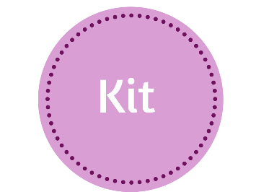Most ladies will have some clothes & shoes suitable for starting our jogging course. Any cotton T Shirts will do including the rather dodgy ones you keep for doing the painting (that you never get round to!)
However you will quickly work out what feels comfortable for you and those horrid technical fabric tops suddenly become more appealing as they wick away the sweat leaving you warm and dry. Lidl, Sainsbury’s and Tesco all do a good line in fitness kit as do the local sports shops.

The most important equipment for you to have specifically designed for sport are a decent bra and some running shoes. Purchase your bra at any reputable shop, Up and Running, Bat and Ball Sports, John Lewis, M and S or if you prefer online shopping, Wiggle, Booby Doo or Sports Direct.
Here is a review of 5 of the best bra’s on the market at the moment.
Start by wearing the trainers you have and we will advise you on when or why to get new ones, once you start. If you don’t have any shoes to wear then we advise getting specially fitted by trained advisors such as those in Up and Running and Bat and Ball Sports. Mention SLJ for a discount!

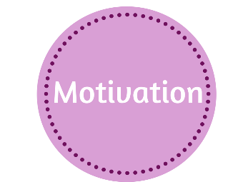It can be really hard to make the decision to embark on a fitness program but there are a few things that can ease the way.

- Tell someone (or the world on Facebook!) what you are doing & encourage a friend to join you. Being accountable to someone can be a huge motivator in getting and keeping you on track.

- Tell NO ONE – unlike telling someone, telling no one what you are doing can also be a great incentive. Enjoying the stunned faces as you cruise happily down the road because you’ve been training and they didn’t know is great!

- Enter a race. Find a 5k fun run that happens once the beginner course is over and enter it. Having a target to aim for plus raise money for a good cause helps keep you on track.

- Don’t expect miracles overnight. Some say it takes 12 weeks to form a habit so take small steps and change will come.

- Put the course dates in your diary, and where ever possible try to avoid anything else clashing with them. Offer to share babysitting with a friend if childcare is an issue.

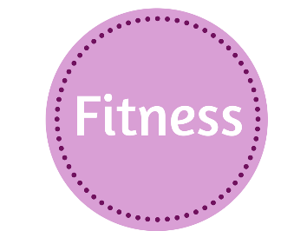If you have any health issues or have had an injury seek medical advice before you start. In the period before the course try to increase your activity each day by making small changes.

- Leave items at the bottom of the stairs and take them up throughout the day.

- Play active games with the kids, they don’t care if you aren’t any good!

- Each week before the course start try to go for a walk at least once. Aim for 30 minutes, start slowly for 10 minutes, increase the speed so your breathing becomes heavier for 15 minutes then slow down for the final 5 minutes.

- If you commute to work, try to park the car in the furthest part of the car park, yes, it will take longer to walk but if you don’t make changes, you won’t get fitter.

- Avoid using the escalator or a lift, use the stairs where you can.

- When you are on the phone- stand up, move around but don’t sit.

- Stand on one leg when you are cleaning your teeth – 60 seconds on each leg!

Staying hydrated is an important part of feeling good while we exercise and many people don’t drink enough water on a day to day basis. Aim to drink 1.5 – 2litres per day, this can be as cold or warm water, diluted juices or squash or herb/fruit tea’s. Watch the unnecessary extra sugar in juice and squash though.

Eat before you run- Avoiding meals will not help you lose weight and will make you feel dreadful on a run. If you are pushed for time in the morning try different breakfasts to see what works for you. If you are on our evening course eat lunch as usual & have a small snack about 1.5 - 2 hours before the class. You won’t need more than that.
Choose foods that are not loaded with fat and sugar (which will give you a sudden burst of energy, then your blood sugar drops rapidly leaving you craving more sugar).

Ideas for breakfast
Porridge with honey, berries or banana
Granola with fruit & yoghurt
Scrambled egg with tomato and avocado
Wholemeal toast with peanut butter
Pre evening run snacks
1 small slice Malt loaf with peanut butter or honey
A banana
Small hand full of nuts and seeds

